PRACTICAL-8 TREES
Aim:- Level Order Traversal in Trees
Theory:- Here we have created a structure of trees along with structure of queue with implementation using queue. In level order traversal we first if root is not present then null otherwise we create a queue structure which initializes front and rear to null. We first enqueue root in the queue. Then we dequeue the element print it, enqueue its left and right child into the queue if not null until the queue is empty.
Code:-
#include <stdio.h>
#include <stdlib.h>
struct TreeNode
{
int data;
struct TreeNode *left, *right;
};
struct TreeNode *createTreeNode(int data)
{
struct TreeNode *newNode=(struct TreeNode*) malloc(sizeof(struct TreeNode));
newNode->data=data;
newNode->left=newNode->right=NULL;
return newNode;
}
struct QNode
{
struct TreeNode *data;
struct QNode *next;
};
struct Queue
{
struct QNode *front, *rear;
};
struct Queue *createQueue()
{
struct Queue *q=(struct Queue *)malloc(sizeof(struct Queue));
q->front=q->rear=NULL;
return q;
}
void enqueue(struct Queue *q,struct TreeNode *node)
{
struct QNode *newNode=(struct QNode *)malloc(sizeof(struct QNode));
newNode->data=node;
newNode->next=NULL;
if (q->front==NULL)
{
q->front=q->rear=newNode;
return;
}
q->rear->next=newNode;
q->rear=newNode;
}
struct TreeNode *dequeue(struct Queue *q)
{
if (q->front==NULL)
return NULL;
struct QNode *temp=q->front;
struct TreeNode *node=temp->data;
q->front=q->front->next;
if (q->front == NULL)
q->rear = NULL;
free(temp);
return node;
}
void levelOrderTraversal(struct TreeNode* root)
{
if (root==NULL)
return;
struct Queue *q=createQueue();
enqueue(q,root);
printf("\nLevel Order Traversal: ");
while (q->front!=NULL)
{
struct TreeNode *current=dequeue(q);
printf("%d ", current->data);
if (current->left)
enqueue(q,current->left);
if (current->right)
enqueue(q,current->right);
}
printf("\n");
}
int main()
{
struct TreeNode *root=createTreeNode(1);
root->left=createTreeNode(2);
root->right=createTreeNode(3);
root->left->left=createTreeNode(4);
root->left->right=createTreeNode(5);
root->right->right=createTreeNode(6);
root->left->right->left=createTreeNode(7);
root->right->right->left=createTreeNode(8);
levelOrderTraversal(root);
return 0;
}
Output:-
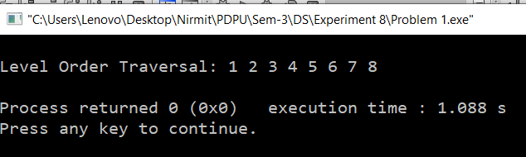
Time Complexity:- O(n) as every node is visited one
Space Complexity:- O(n) worst case as queue stores node wise.

